Issue Order
Two Steps : Pick and Confirm
1. Pick
Once Pick the Issue Order, the quantity will deduct from the Qty Available and will add to the On Transfer - Out Column for that warehouse.
(Example : Warehouse is Centrepoint and quantity is 1 then the Scenario will like that :)
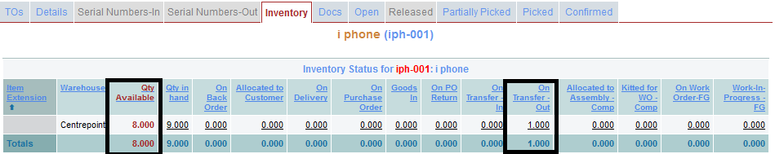
2. Confrim
After Confirming the Issue Order, the quantity will deduct from Qty in hand Column.


