Issue Order to GL
After confirming the issue order, the created voucher will automatically posted to GL and following accounting entries will be created :
GL Interface Type/[Account] | Account Usage | Sub-account | Currency | Dr | Cr | Notes
Consumables | Ledger |  | Prime | Inventory Transaction Value
COST OF SALES | Ledger |  | Prime |  | Inventory Transaction Value

Example
1. Performs Receipt Order
Standard Price: SGD2000, Quantity: 1, Inventory Transaction Value: SGD20000
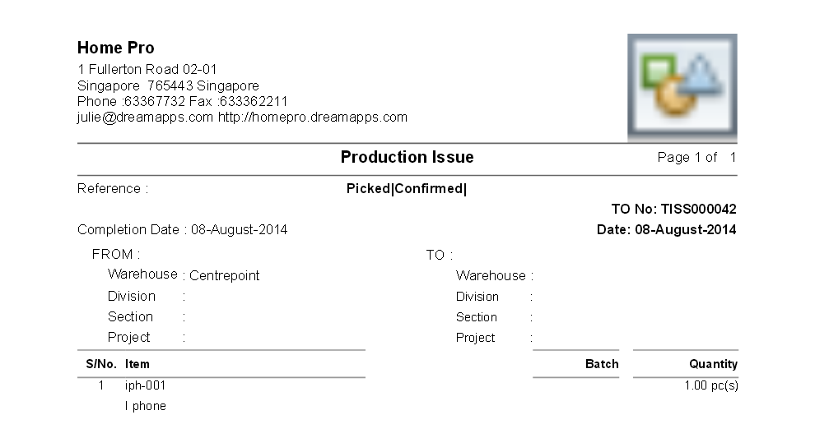
2. After posting the voucher to GL :
GL Interface Type | Sub Account | Currency | PrimeDr | PrimeCr | BaseDr | BaseCr | Notes
Consumables |  | SGD | 1*2000 = 20000 |  | 20000
COST OF SALES | CUS-000001 | SGD |  | 1*2000 = 20000 |  | 20000
Totals |  |  |  |  | 20000 | 20000


