Customer Order
Three Steps for Affecting the Inventory : Processed line item in CO, Create DO and Confirm DO
1. Processed line item in CO
At the time of creating CO, after adding and processing the line item, the quantity will deduct from the Qty Available and will add to the Allocated to Customer column's for that warehouse.
(Example : From Warehouse is Centrepoint and Qty Available was 17, Qty in hand was 17. The ordered quantity is 1 then Scenario will like that :)
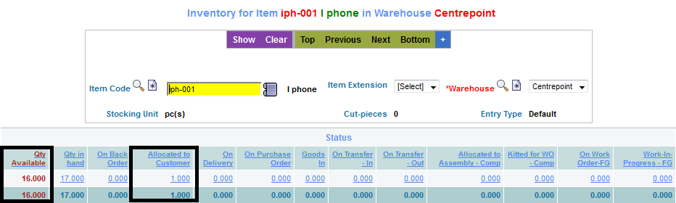
2. Create DO
After Approving the CO, when Create DO is clicked, the quantity will add to the On Delivery column.
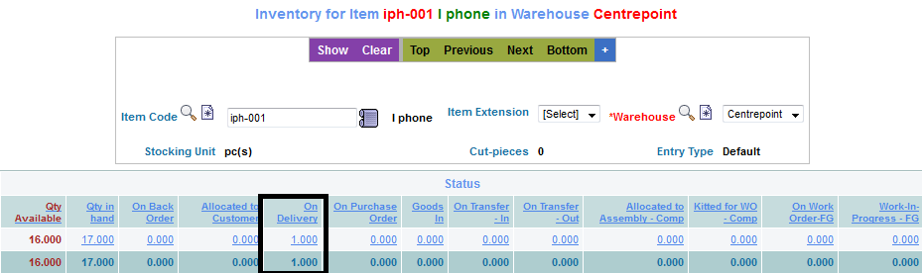
3. Confirm DO
After Confirming the DO, the quantity will deduct from the Qty in hand column.


