Purchase Order
Three Steps for Affecting the Inventory : Add line item in PO, Create GRN and Confirm GRN
1. Add line item in PO
At the time of creating PO, after adding the line item, the quantity will add to the On Purchase Order column for that warehouse.
(Example : From Warehouse is Centrepoint and quantity is 10 then Scenario will like that :)
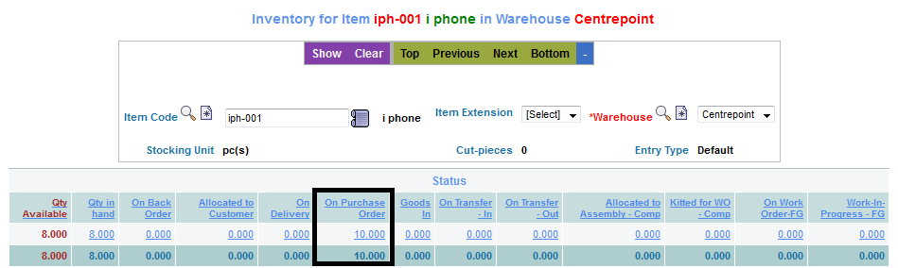
2. Create GRN
After Approving the PO, when Create GRN is clicked, the quantity will add to the Goods In column.
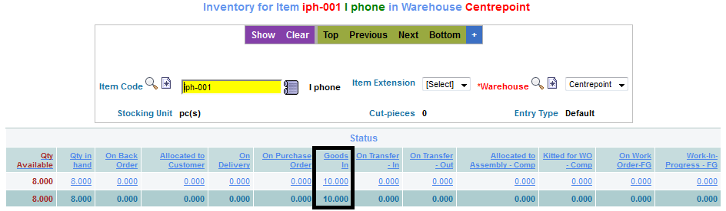
3. Confirm GRN
After Confirming the GRN, the quantity will add to the Qty Available and Qty in hand column's.


