Receipt Order to GL
After confirming the receipt voucher will automatically posted to GL the and then the following accounting entries will be created :
GL Interface Type/[Account] | Account Usage | Sub-account | Currency | Dr | Cr | Notes
STOCK IN HAND | Ledger |  | Prime | Inventory Transaction Value
COST OF SALES | Ledger |  | Prime |  | Inventory Transaction Value

Example
1. Performs Receipt Order
Standard Cost: 1000, Quantity: 10, Inventory Transaction Value: 10000SGD
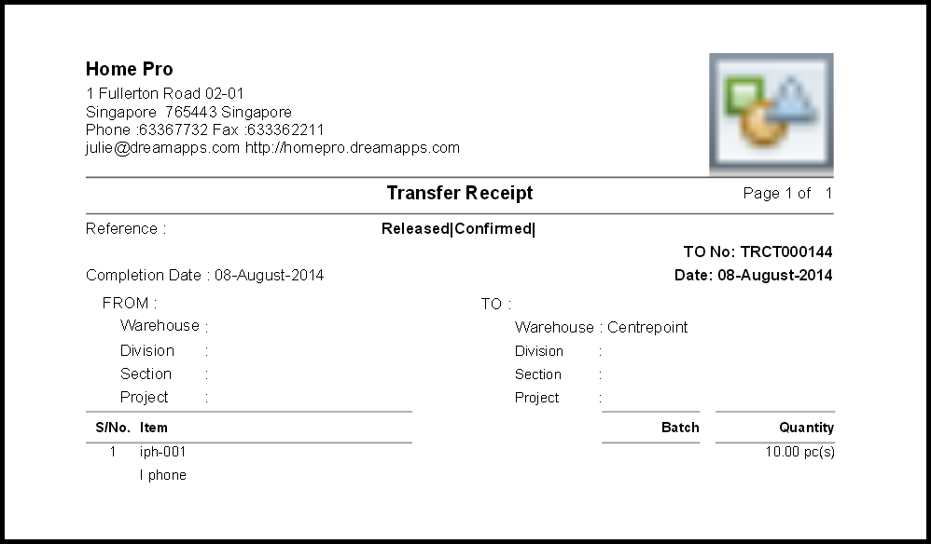
2. After posting the voucher to GL :
GL Interface Type | Sub Account | Currency | PrimeDr | PrimeCr | BaseDr | BaseCr | Notes
STOCK IN HAND |  | SGD | 10*1000 = 10000 |  | 10000
COST OF SALES | CUS-000001 | SGD |  | 10*1000 = 10000 |  | 10000
Totals |  |  |  |  | 10000 | 10000


