Transfer Order
Two Steps : Release and Confirm
1. Release : Once Release the Order the quantity will affect on the On Transfer - In Column.
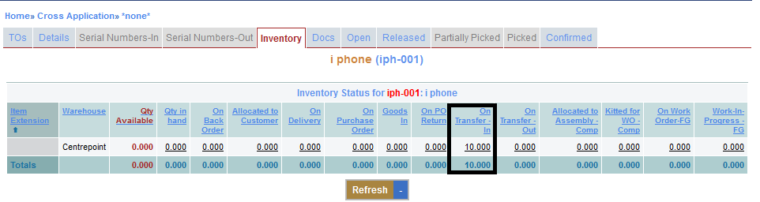
2. Confirm : After Confirming the Order the quantity will affect on the Qty Available and Qty in hand Columns.


