Licensing
Every installation of DreamApps on a server needs to be licensed before it can be used. From any browser, run initdb to apply, upgrade, renew or install your license.
http://your-domain-or-ip-address/da/initdb

New Installation
This is for a server which was never licensed before.
- Once you are in initdb, you will see the following screen.
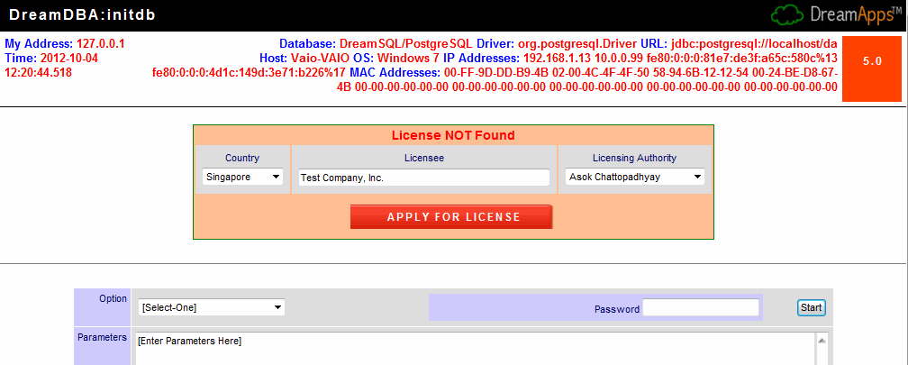
- Select your Country, enter your organization name in Licensee and select a Licensing Authority that you believe knows about your acquiring DreamApps legitimately. If in doubt, ask your vendor. Now click on APPLY FOR LICENSE and you'll get a screen back that looks like something like the following. At this point the licensing authority will be notified of your application.
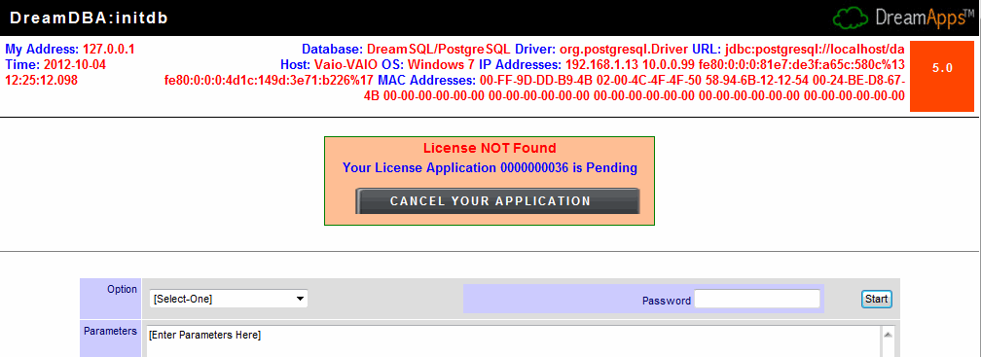
- At this point you will continue to see the above screen whenever you go to initdb until your license is approve or rejected. However, if you think you made a mistake you can cancel your application by clicking on CANCEL YOUR APPLICATION. That will bring you back to the previous screen and you can apply again. Normally, there is no reason for the licensing authority to reject your application, unless he/she believes that you obtained DreamApps by illegitimate means. In that case you need to get back to your vendor and correct that impression. Once your application is approved, the above screen will be replaced by
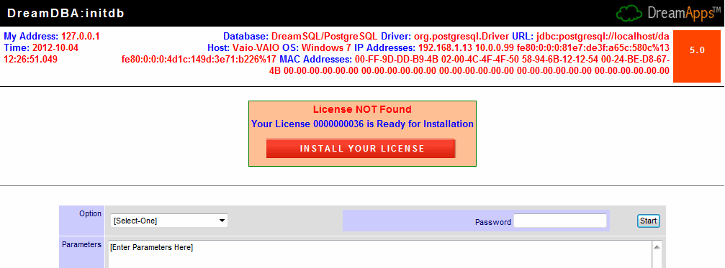
- Simply click on INSTALL YOUR LICENSE and restart Tomcat.

Migration
This is for a server which already had a license installed for a previous version of DreamApps. Before you migrate, ensure that you totally replace the html and the WEB-INF/lib folders. Do not overwrite the existing folders. Rename them as, say, html-old and lib-old respectively. If you are migrating also the applications, you should also replace WEB-INF/resource and WEB-INF/reports folders. Restart Tomcat and run initdb from a browser, as explained earlier.
- Once you are in initdb, you will see the following screen.
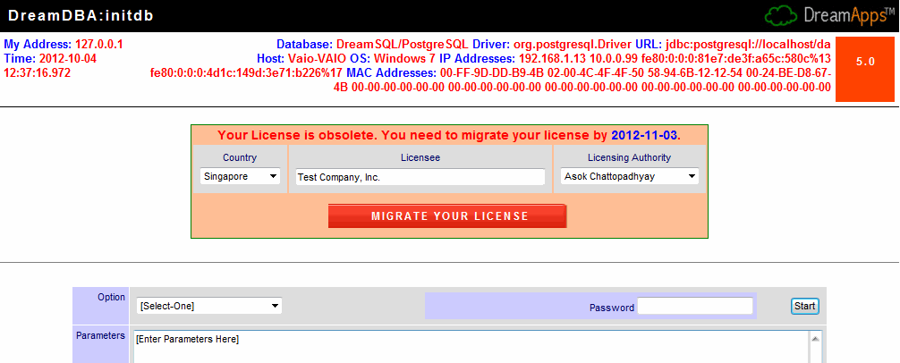
- Select your Country, enter your organization name in Licensee and select a Licensing Authority that you believe knows about your acquiring DreamApps legitimately. If in doubt, ask your vendor. Now click on MIGRATE YOUR LICENSE. This will bring you to the license pending screen. Thereafter, follow the instructions as in the previous section.

Upgrades
If you have a current license and you need to upgrade it for additional modules, periods, etc, click on the version number (5.0) on the top-right corner of the initdb screen. This will expose the UPGRADE YOUR LICENSE button. Click on it. This will bring you to the license pending screen. Thereafter, follow the instructions as in the previous section.


