Portal
- This is an integrated admin portal for you to manage the sites, their settings, access rights from anywhere and anytime.
- You also Use this to congfigure or maintain your company database of items, costumers, suppliers, brands, price,tables, accounts,receipts,payments, etc…
- Portal is a term, generally synonymous with gateway.
- Typical services offered by portal sites include a directory of Web sites, a facility to search for other sites, e-mail, stock quotes, and sometimes a community forum.
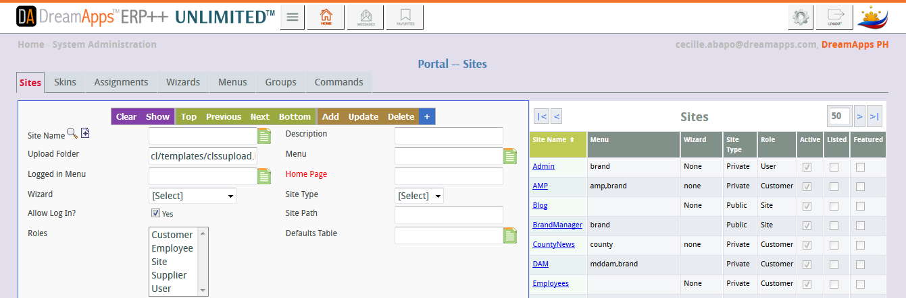
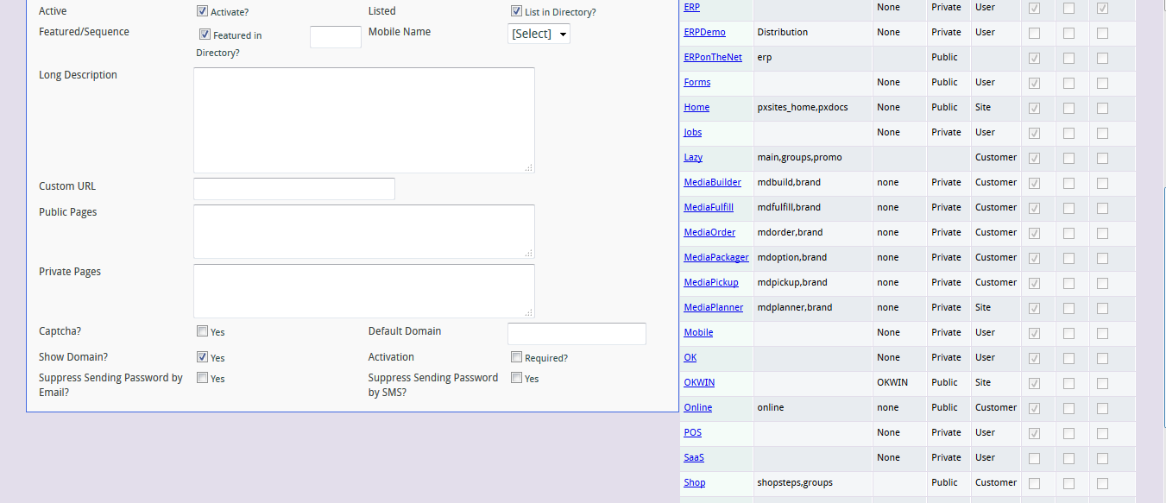
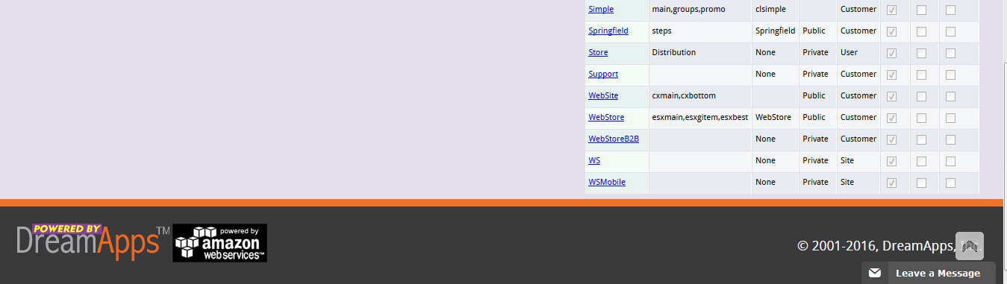
Skin
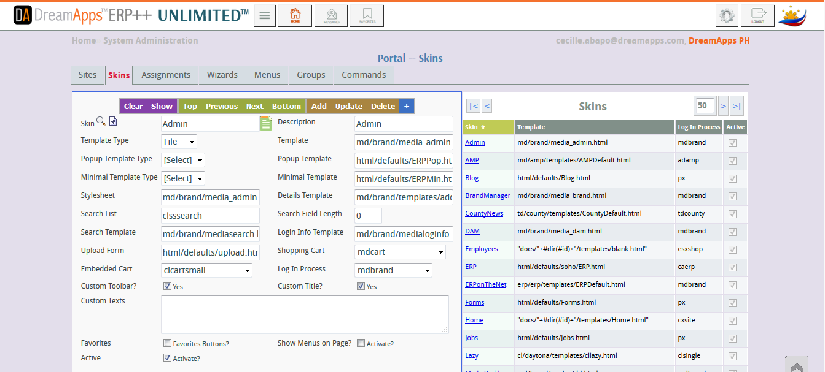


Assignment


