Revised Purchase Order - Local
Four Steps for Affecting the Inventory : 1. Add line item in PO, 2. Revised quantity, 3. Create GRN and 4. Confirm GRN

Create Requisition
Go to Purchasing » Requisition
- Add Local Supplier in the requisition header:
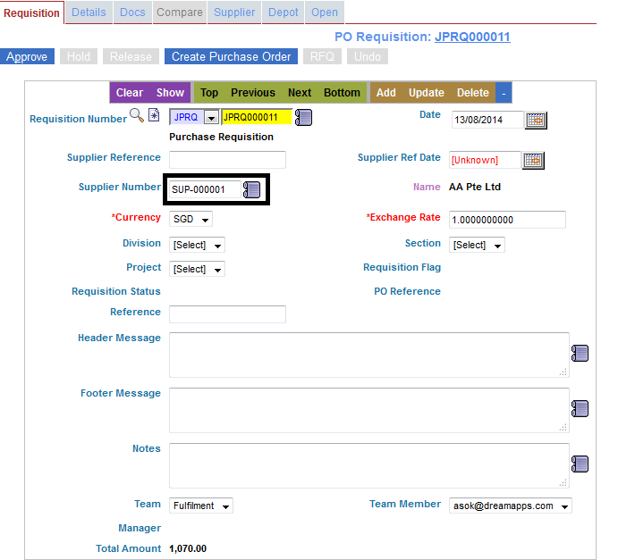
- Go to Requisition Details Tab Add Item Code, Quantity, Warehouse
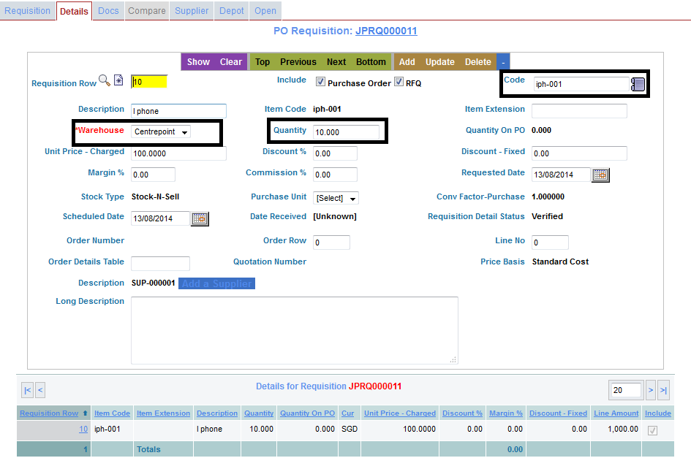
- Approve the Requisition
(N.B : no change in the inventory)

Create RFQ
Create a number of RFQ's for individual Suppliers
- Click RFQ on the Requisition header
- Change the price in the detail RFQ's tab, as per the quotation that received from the supplier
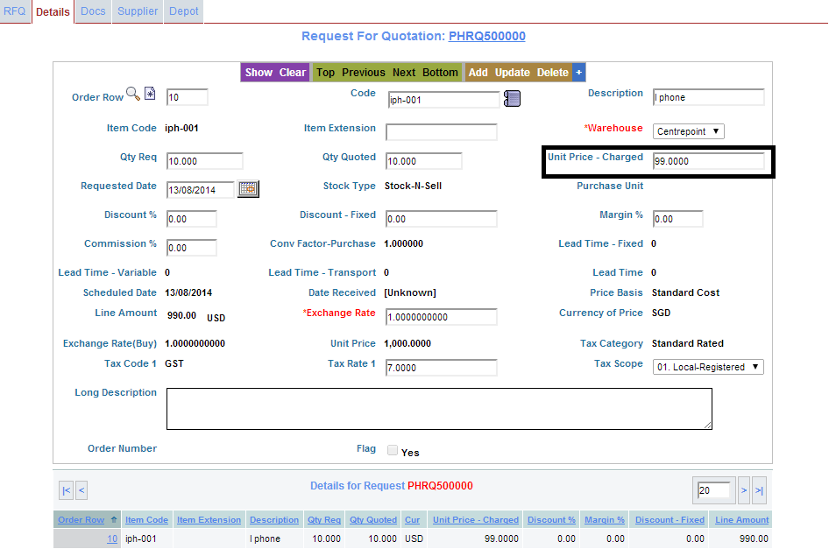
- Compare the RFQ's, Click to select the RFQ and generate the PO
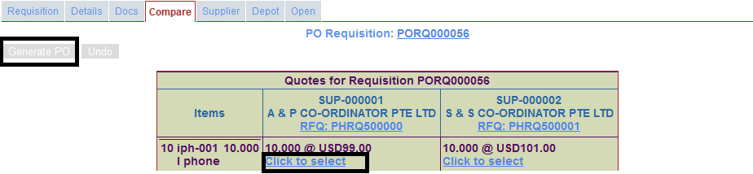
(N.B : no change in the inventory)

Create PO
1. Add line item in PO
At the time of creating PO, after adding the line item, the quantity will add to the On Purchase Order column for that specific transacted warehouse.
Example : Item code is iph-001, Warehouse is Centrepoint, Qty Available was 8, Qty in hand was 8 and purchased quantity is 10 then Scenario will like that :
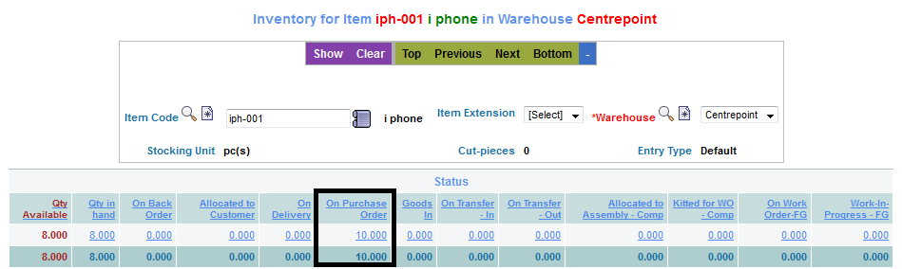
- Approve the PO
2. Revise PO
- After click the Revise command the previous PO will be closed and the new PO number will be generated.
- After changing the quantity and another details. the inventories On Purchase Order Column will be affected.
Example: Revised quantity is 20 then the scenario will like that :
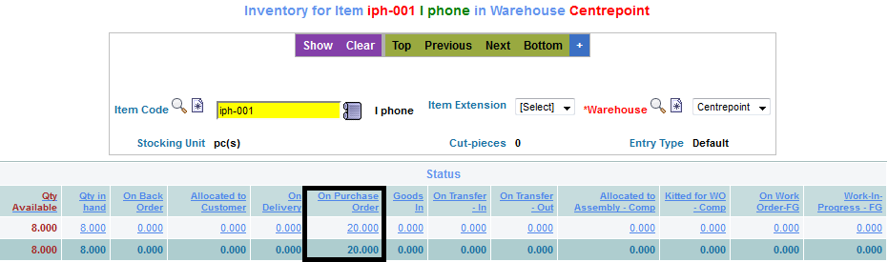
- Approve the revised PO.

Create GRN
2. Create GRN
- Create GRN is clicked, the quantity will add to the Goods In column.
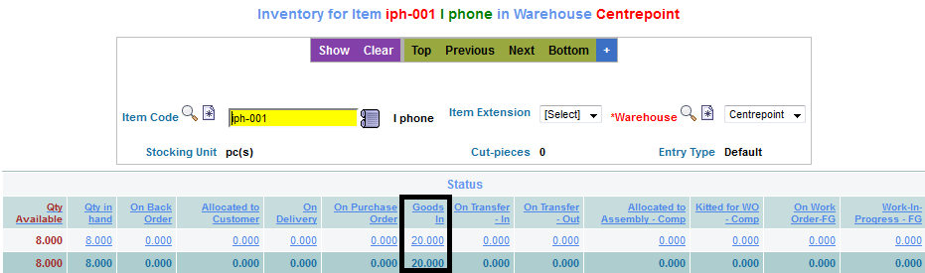
- 3. Confirm GRN
After Confirming the GRN, the quantity will add to the Qty Available and Qty in hand column's.
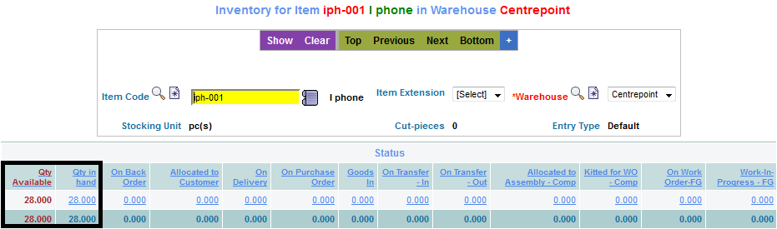

Invoice
* Click the Invoice

