Custom Docs
Documents that prints out a transaction is usually accessible from the screen header. You can click on the link and print, save or email a document straight away.

Customizing Documents
Customizing a document format is straight forward. Once you have created a custom format (Crystal or Jasper), you simply drop them into the custom folder in creports and the system will pick up the custom format instead of the standard format, as long as you add the custom folder in the field Custom Features in The Business tab.
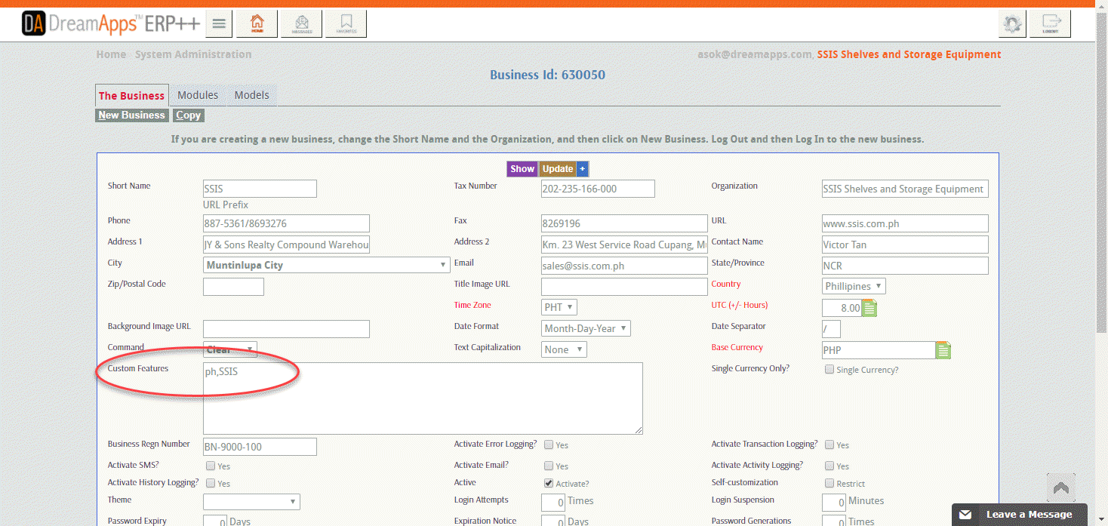

Additional Documents
However, when you do not want to forsake the standard formats and want to add in additional format(s), you need to name the custom formats uniquely and add in these formats in System Data tab in Cross Application–>Settings.
Your context must be Custom Docs and key must be the document name. You can have multiple documents by simply varying the Row number.
Here is an example of an additional document Order Form for the document opord (Customer Order).
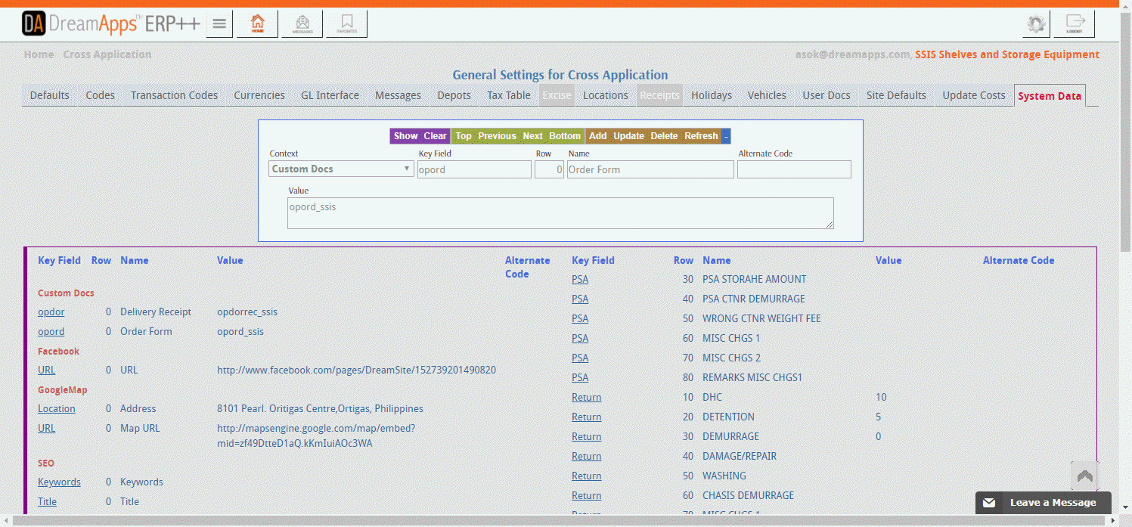
This will cause the Additional Custom Document in the Order header.


