User Customizations
DreamApps allows individual users to customize forms to suit their personal needs

Who
By default all users can customize the forms they have access to, and link or copy customizations shared by other users. Users can be selectively restricted from doing so by setting the Self-customization flag in the page Users in System Administration. The flag can be set for all users in a business by setting the flag in the page Business in System Administration.

What
Currently, the users can customize content by hiding or showing individual fields and/or changing field captions.

How
Each page/tab displays a generic Settings icon
25
When the user hovers over the icon, the settings menu is exposed.
Here are the options:
- Organize – Apply customizations to the page.
- Share – Share your customizations so that others can link to or copy from them.
- Link – Link to customizations of other users. This creates a dynamic link to the other user's customizations. Any future changes to those would automatically be inherited by the current user.
- Copy – Copy from customizations of other users. This copies the customizations from another user as a snapshot and the current user can make further changes. Any future changes by the other user will have no effect on the current user.
- Restrict – Disallow sharing.
- Unlink – Remove links.
- Clear – Clear customizations.
Selecting Organize transforms the page into a Customization Canvas allowing the user to apply customizations to that page. Clicking on rest of the options pops up a Utility Window to act on. Here are the details:

Customization Canvas
The customization canvas is an editable page for editing custom captions and showing/hiding fields. Here is an example:
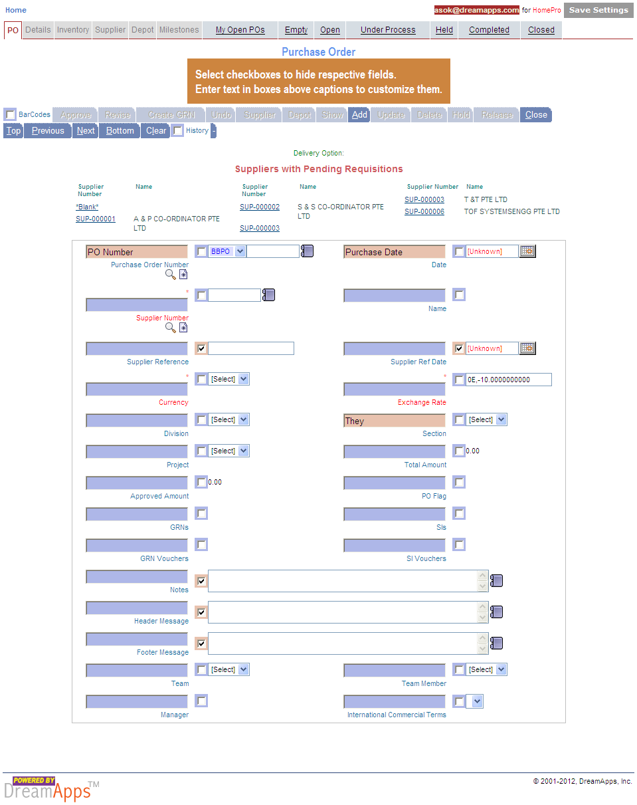
Notice that the Settings icon on the top right corner has been replaced by a Save Settings button.
Click on the button after changes to save them.

Utility Window
The utility window allows you to specify sharing, linking,copying, restricting, un-linking and clearing customizations. It has two buttons – one, that would affect only the current page and the other, all pages.


